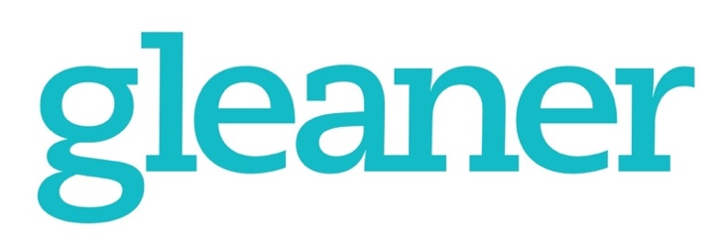

5709 N 20th St, Ridgefield, WA 98642
360.857.7200 • info@nwadventists.com • NWAdventists.com
2024 Deadlines – Reaching Across Generations
Deadline Structure: Email – Each Monday Web – Typically First Mondays Print – Typically Third Mondays
Print  Issue | Web | Content Deadline | Cover Feature | Medium | Other Feature | Inserts  to Press | Conf  Inserts | Perspective | Target Mailing Date | Generations to Highlight & Notes
Jan/Feb 2024 |  | Nov. 6, 2023 | Generations of Light | print | Intergenerational Ministry | Dec. 7, 2022 | OR | LL / KM / NM | Dec. 20, 2023 | Silent Gen
 | February | Jan. 9,  2024 | Diversity | web | Black History Month
Mar/Apr |  | Jan. 16 | WWU / Education | print | Summer Camps/  Camp Meeting dates | Feb. 8, 2023 | ID | LL / KM / NM | Feb. 23, 2024 | Gen Z / Alpha Gen
 | April | Feb. 5 | EndItNow | web |  |  |  |  |  | Sexual Assault Awareness Month
May/Jun |  | March 18 | Unusual Outreach & Digital Media | print |  | April 11 |  | LL / KM / NM | April 24 | Millennials / Gen Z
 | June | May 6 | Politics & Christianity | web |  |  |  |  |  | Political Season / Also Immigrant Heritage / Refugee Awareness month
July/Aug |  | May 20 | Adventist Health | print | Caring Heart /  School List Call-out | June 13 | ID | LL / KM / NM | June 26 | Baby Boomers
 | August | July 8 | Native Ministries | web
Sept/Oct |  | July 22 | Women in Pastoral Ministry / NAD | print | Community Service | Aug. 15 |  | LL / KM / NM | Aug. 28 | Gen X /  Deaf Awareness Month
 | October | Sept. 9 | Hispanic Ministries | web |  |  |  |  |  | National Hispanic Heritage Month
Nov/Dec |  | Sept. 16 | Growing Together / Evangelism | print | Camporee Follow-Up /  Year-end giving | Oct. 10 | ID | LL / KM / NM | Oct.23 | Holiday Season / Best stories of the year
 | December | Oct. 7 | Stewardship | web
Jan/Feb 2025 |  | Nov. 4 | Mission (Focus: TBD) | print |  | Dec 5 |  | LL / KM / NM | Dec. 18

Submit stories to conference correspondents and/or to info@nwadventists.com. Features due one week before Content Deadline.

